Maximum XOR of Two Non-Overlapping Subtrees

CODE:

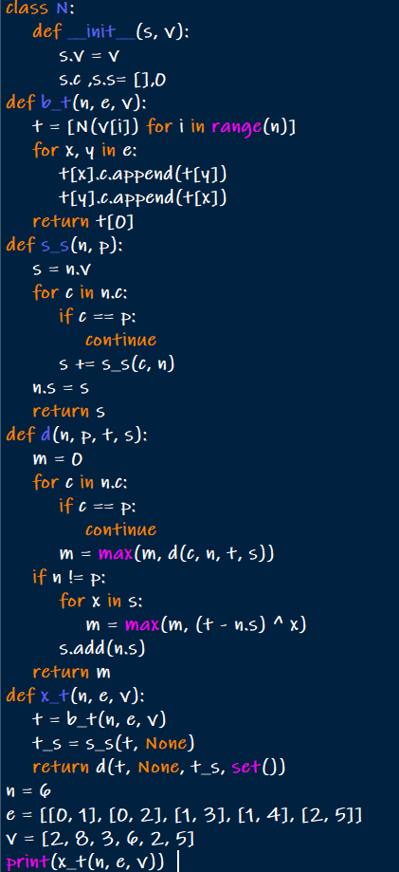

OUTPUT:



Minimum Cuts to Divide a Circle

CODE:

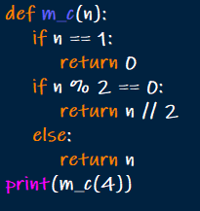

OUTPUT:



Difference Between Ones and Zeros in Row and Column

CODE:

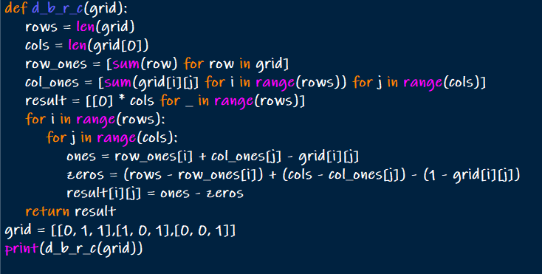

OUTPUT:



Minimum Penalty for a Shop

CODE:

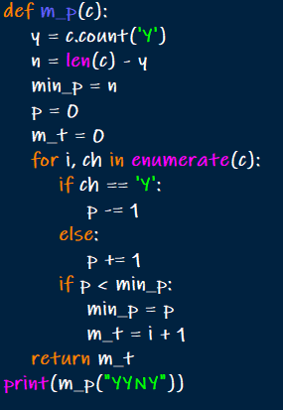

OUTPUT:



Count Palindromic Subsequences

CODE:

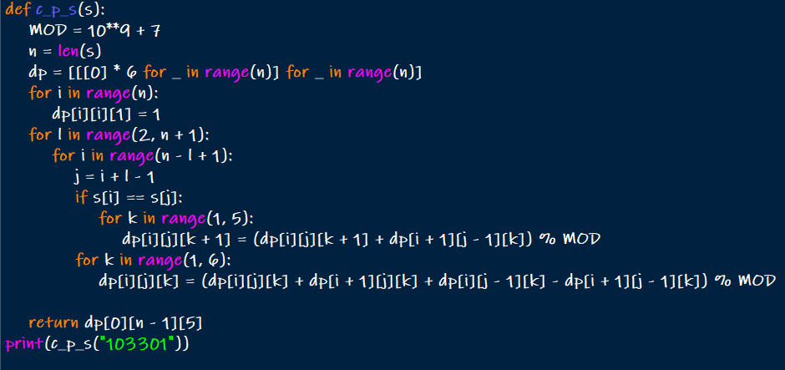

OUTPUT:



Find the Pivot Integer

CODE:

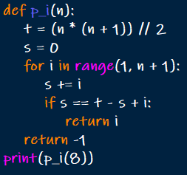

OUTPUT:



Append Characters to String to Make Subsequene

CODE:

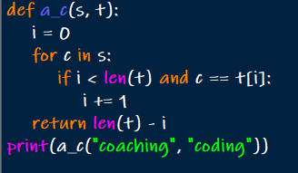

OUTPUT:



Remove Nodes From Linked List

CODE:

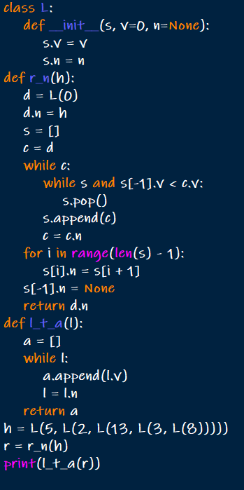

OUTPUT:



Count Subarrays With Median K

CODE:

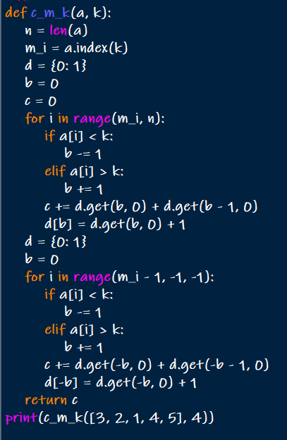

OUTPUT:

